SIMATS ENGINEERING (SAVEETHA SCHOOL OF ENGINEERING)
Department of Computer Science and Engineering

ASSESSMENT TOOL 1– Secure Infrastructure Architecture

Course Code: | CSA5803 | Course Title: | DEVSECOPS ENGINEERING AND APPLICATION SECURITY
CO Assessed: | CO4 – Precision (BL1, BL2, BL3) | Assessment: | Assessment Tool 1
Weightage: | 30% of CIA | Total Marks: | 100
CO 4 Statement: | Design Secure Infrastructure Architecture using DiagrammeR or Drawio.
Student Name: | M.Kruthika Reddy | Reg. No.: | 192465037
Section / Batch: | CSE-Cyber security | Date:
Instructions to Students

- Design a Secure Infrastructure Architecture for the selected application/system using DiagrammeR or Draw.io.
- Include essential components such as Firewall, WAF, Load Balancer, Web/Application Server, Database, IAM, IDS/IPS, and Monitoring/Logging wherever applicable.
- Clearly represent network zones, data flow, security controls, and trust boundaries in the architecture.
- Ensure the diagram is original, professionally formatted, clearly labelled, and submitted along with its editable source file.

Question Type | Focus Area | Questions | Marks
Secure Infrastructure Architecture | Conceptual Understanding | Q1 | Q1 –100
GRAND TOTAL: |  | 100 Marks

Code of Conduct
I M.Kruthika Reddy/192465037 (Name / Reg No) certify that this submission is my original work and that I have adhered to the guidelines specified for this assessment. I understand that any violation of academic integrity rules will result in disciplinary action.
Signature of the Student:

RUBRICS FOR CALCULATION

Criteria | Wt. | Level 4 – Exemplary | Level 3 – Proficient | Level 2 – Developing | Level 1 – Beginning
Understanding of Problem Context | 20% | Clearly understands the problem and accurately identifies all requirements | Good understanding with minor gaps | Basic understanding; some requirements unclear | Poor understanding or misinterpretation of the problem
Application of Concepts | 30% | Accurately applies appropriate concepts to solve complex problems | Applies relevant concepts correctly with minor errors | Applies basic concepts with limited accuracy | Fails to apply appropriate concepts
Problem-Solving Approach | 20% | Logical, well-structured, and efficient approach | Mostly logical approach with minor gaps | Basic approach with some inconsistencies | Illogical or unclear approach
Accuracy of Solution | 20% | Completely correct solution with proper justification | Mostly correct with minor errors | Partially correct solution | Incorrect or incomplete solution
Clarity | 10% | Clear, well-organized, and properly explained solution | Understandable with minor clarity issues | Limited clarity and explanation | Poorly presented and difficult to understand

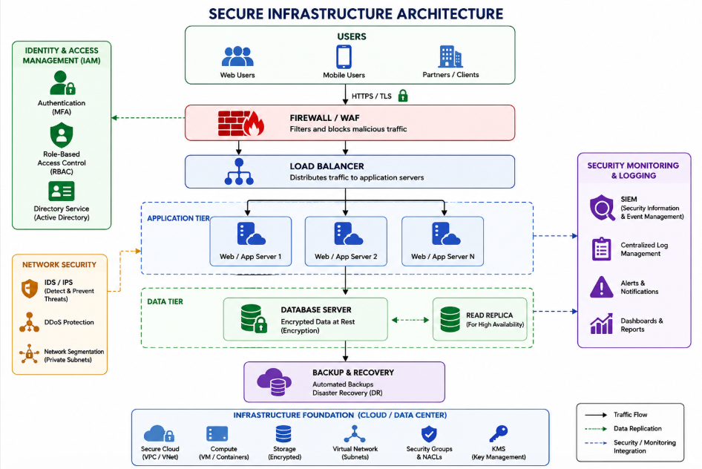

- Secure Access – Users connect through HTTPS/TLS to protect data during communication.
- Firewall/WAF – Blocks unauthorized and harmful traffic before it reaches the system.
- Load Balancer – Distributes traffic between servers to avoid overload.
- Application Servers – Process user requests and provide application services.
- Database Security – Stores important data securely using encryption.
- IAM – Allows only authorized users to access resources using authentication and roles.
- Network Security – IDS/IPS and network segmentation help protect against attacks.
- Security Monitoring – SIEM collects logs and detects suspicious activities.
- Backup and Recovery – Keeps backup copies of data and helps recover after failures or attacks.
- High Availability – Multiple servers and database replicas keep the system available even if one server fails.

